**Fault Tree for the top event “Storage Tank Overflows”**

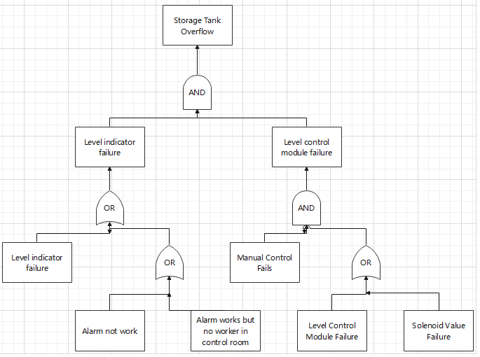

**Recommendations**

* Regularly check and maintain the solenoid, level control module, manual valve, alarm, and level indicator.
* Implement a shift system in the control room to guarantee that operators are always keeping an eye on the space.
* The operator's reaction time is three minutes. Therefore, the operator must receive expert instruction on how to treat a storage tank emergency. Make sure that after the alarm goes off, the proper steps may be completed within a certain amount of time.
* "Or" is more likely to occur than "and" will. To ensure the left half system's reliability, the level indicator needs to be maintained and checked more frequently.
* Once you are aware of the probability, you can use cut set to more precisely identify the primary cause.